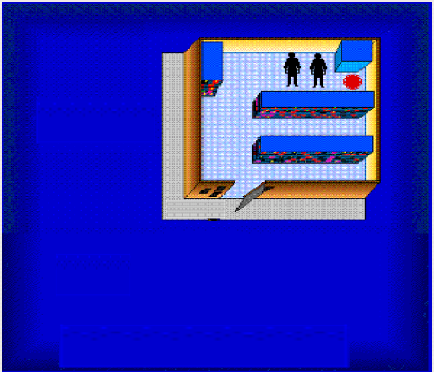

This is what they want. Neither one should be able to see the door but can see the target.

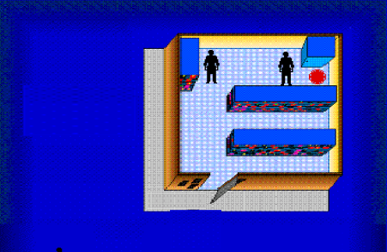

In this example above one person can see the target and the door.

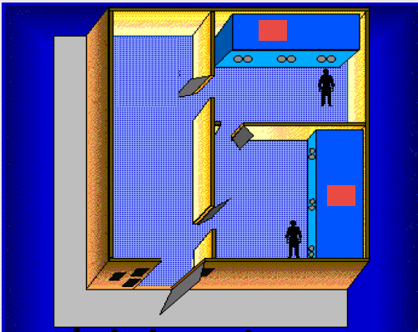

Make the red boxes to appear inside of the boxes they are sitting on.

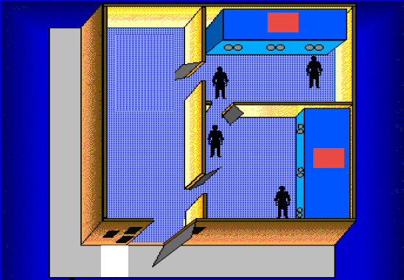

Same here with the red boxes. The door and people placement are very important in all of these pictures.